**Problem 1: Setup and solving for the Lagrangian.**

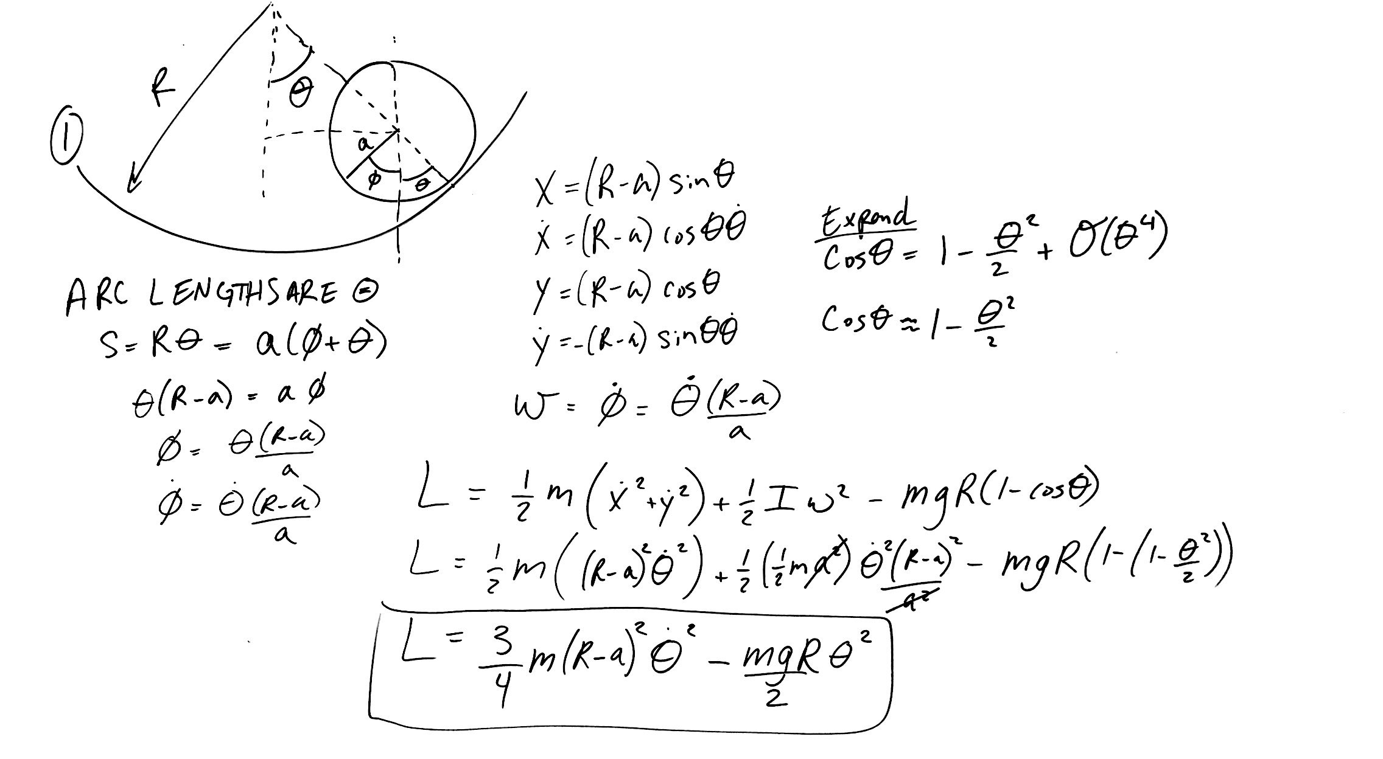

**Solving for the equation of motion and eigenfrequencies.**

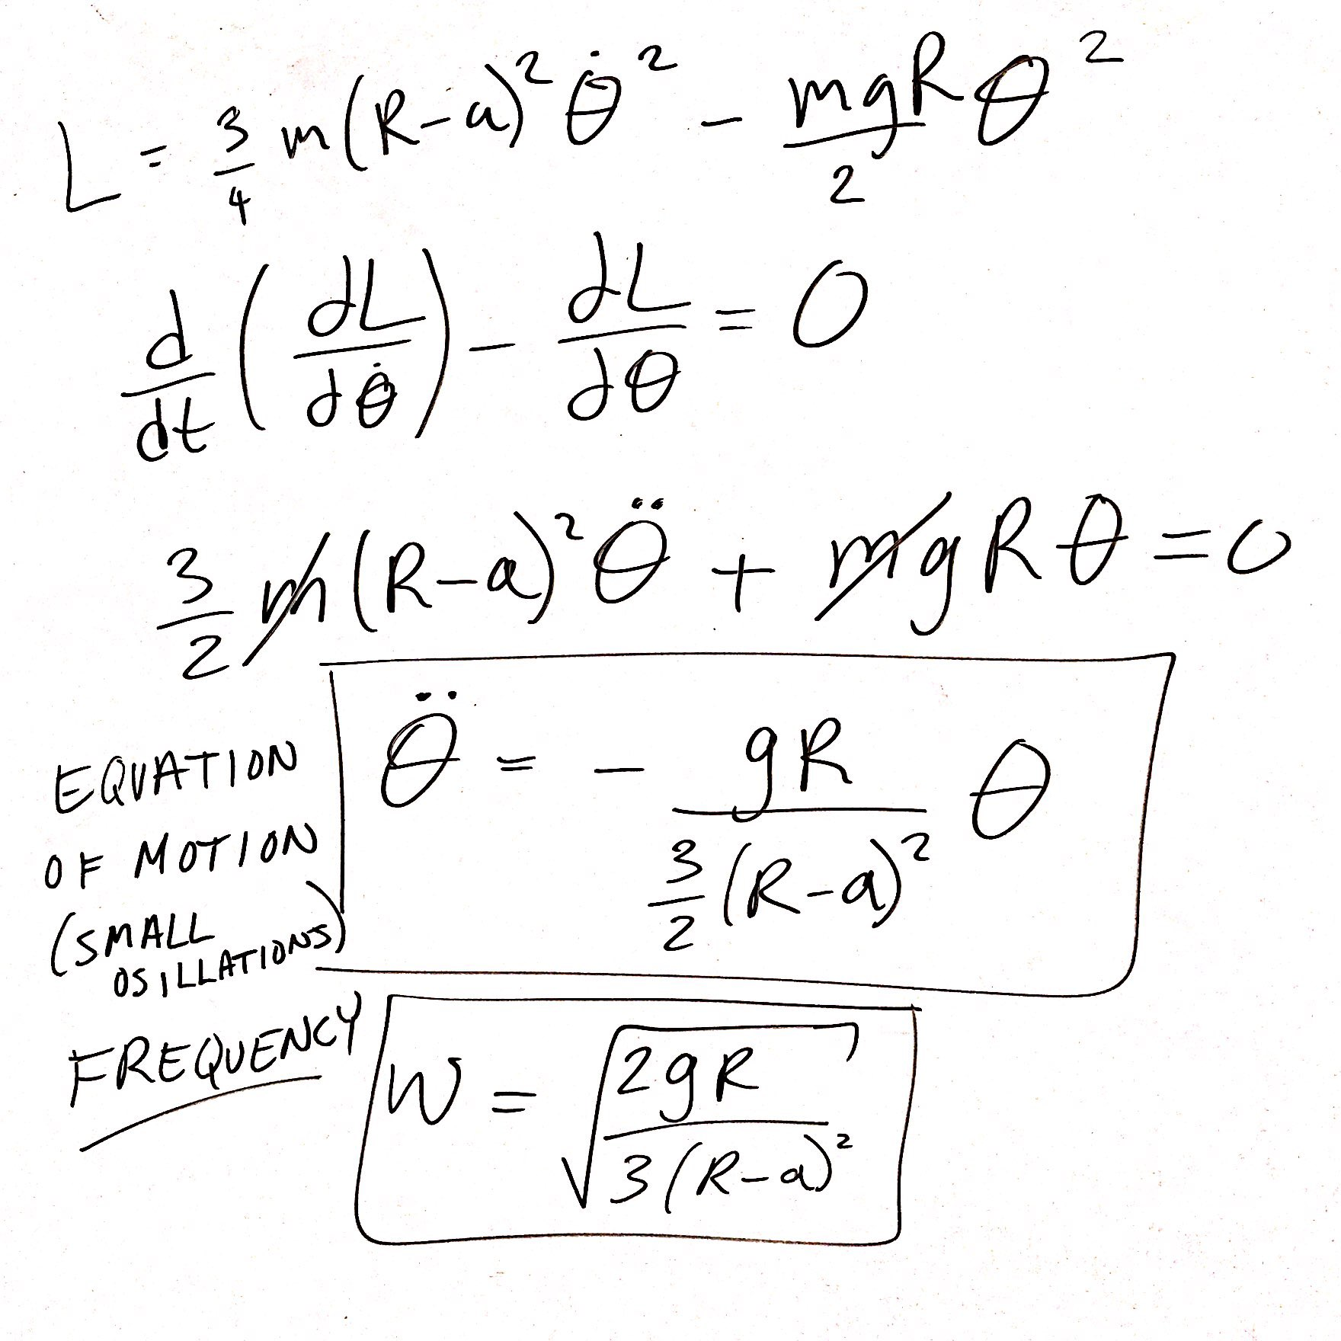

**Problem 2: Setup and solving for the Lagrangian.**

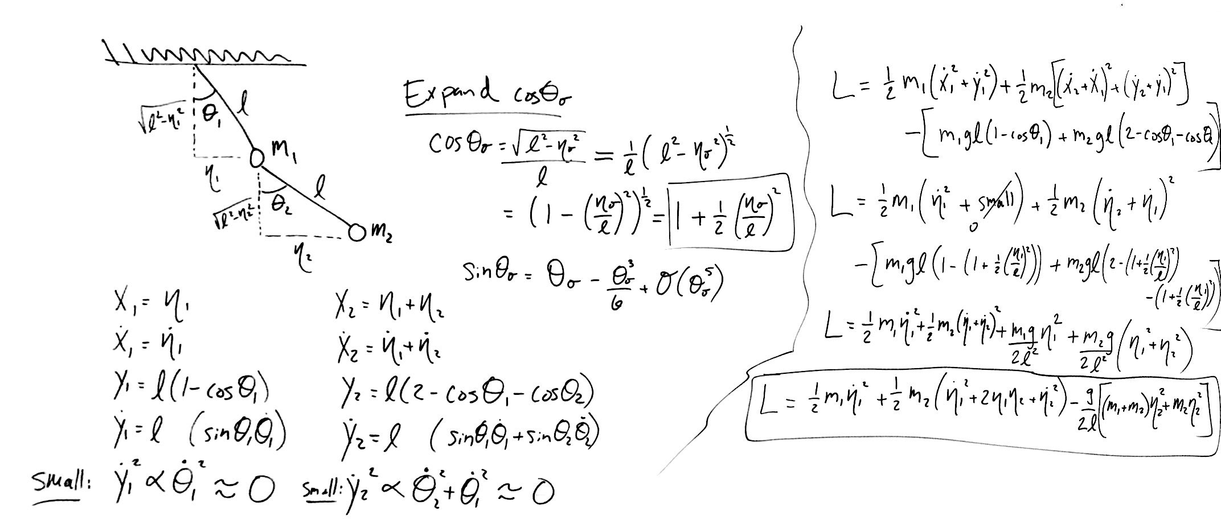

**Solving for mass matrix, potential matrix, and eigenfrequencies.**

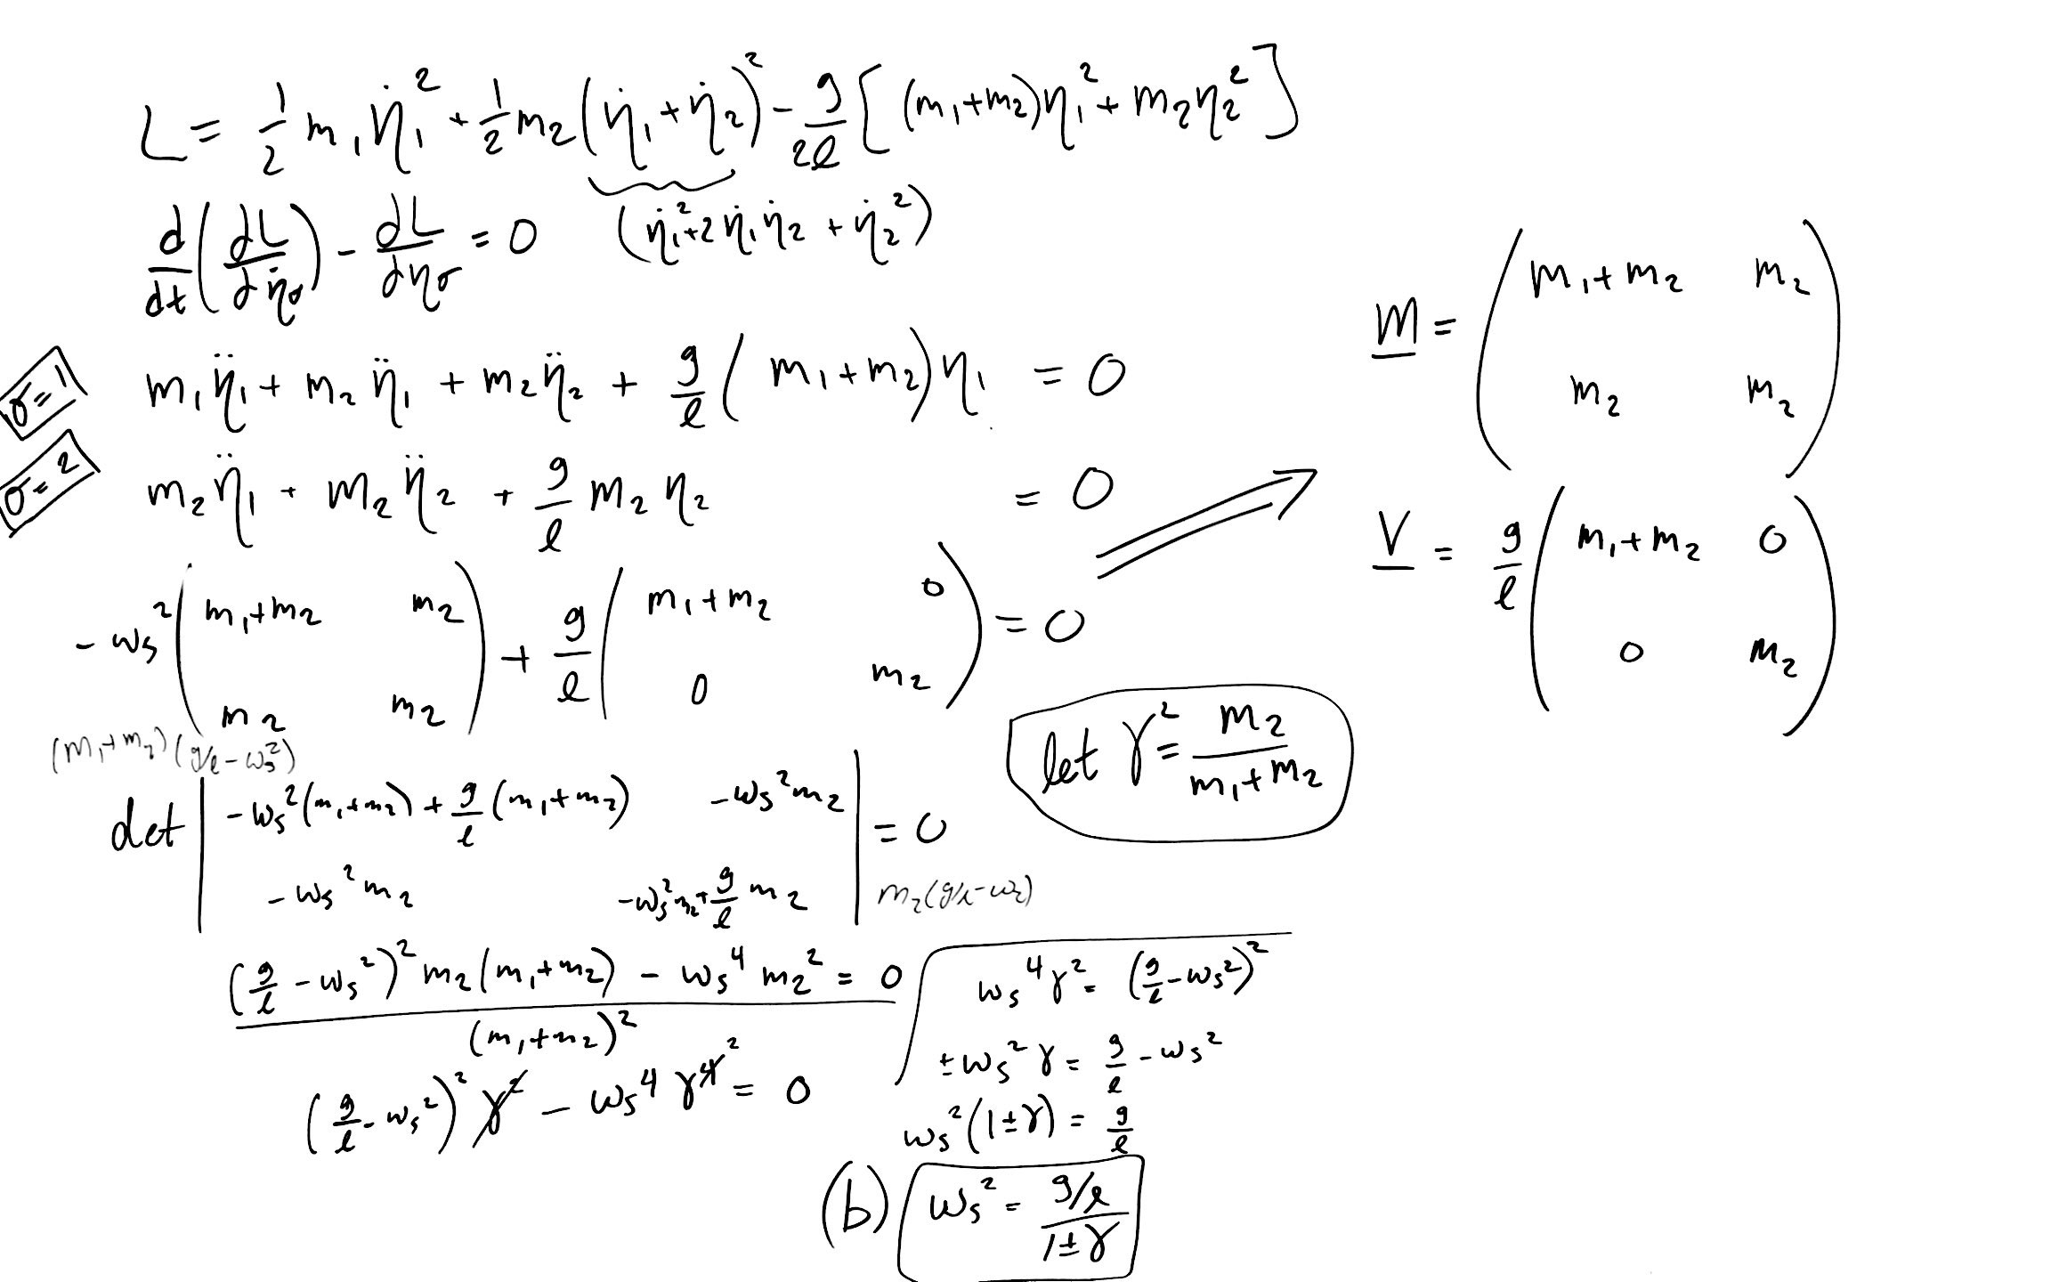

**Solving for the eigenvectors and and normalization:**

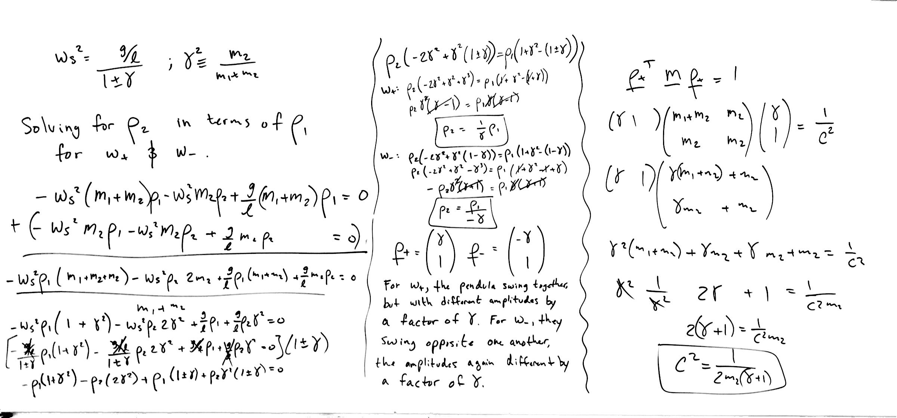

**Normalization and solving for and to match Weihong’s solution.**

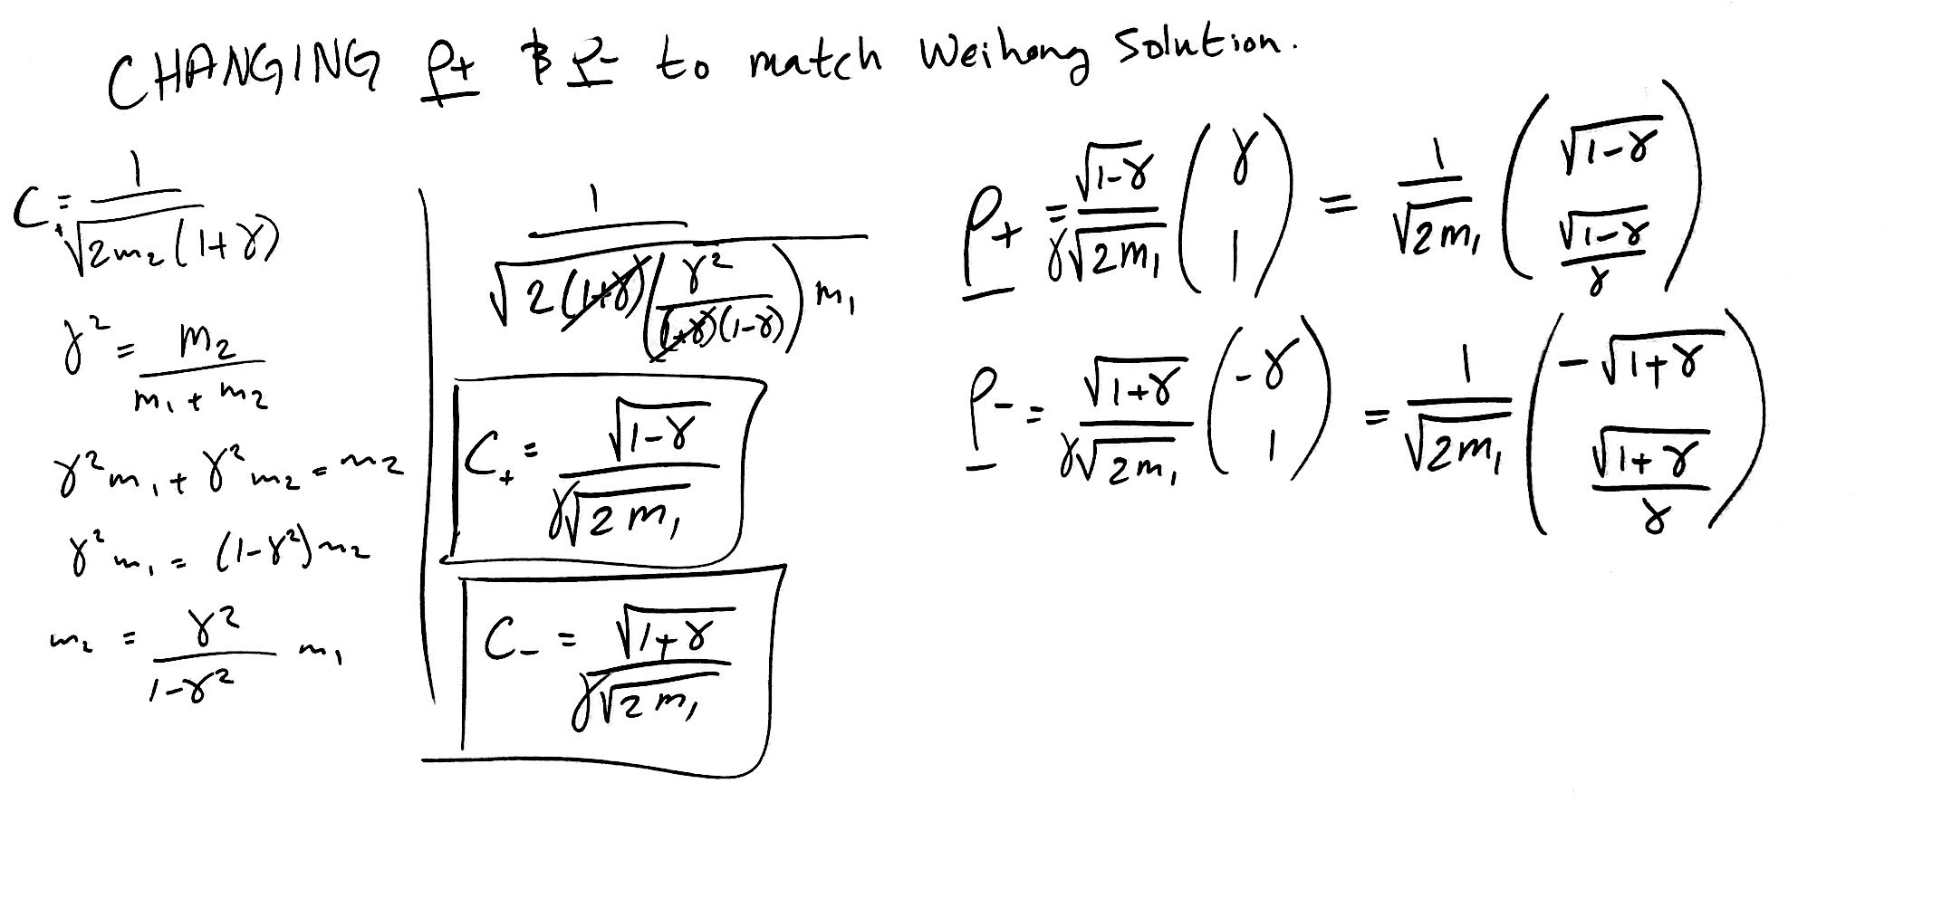

**The modal matrix , and showing that**

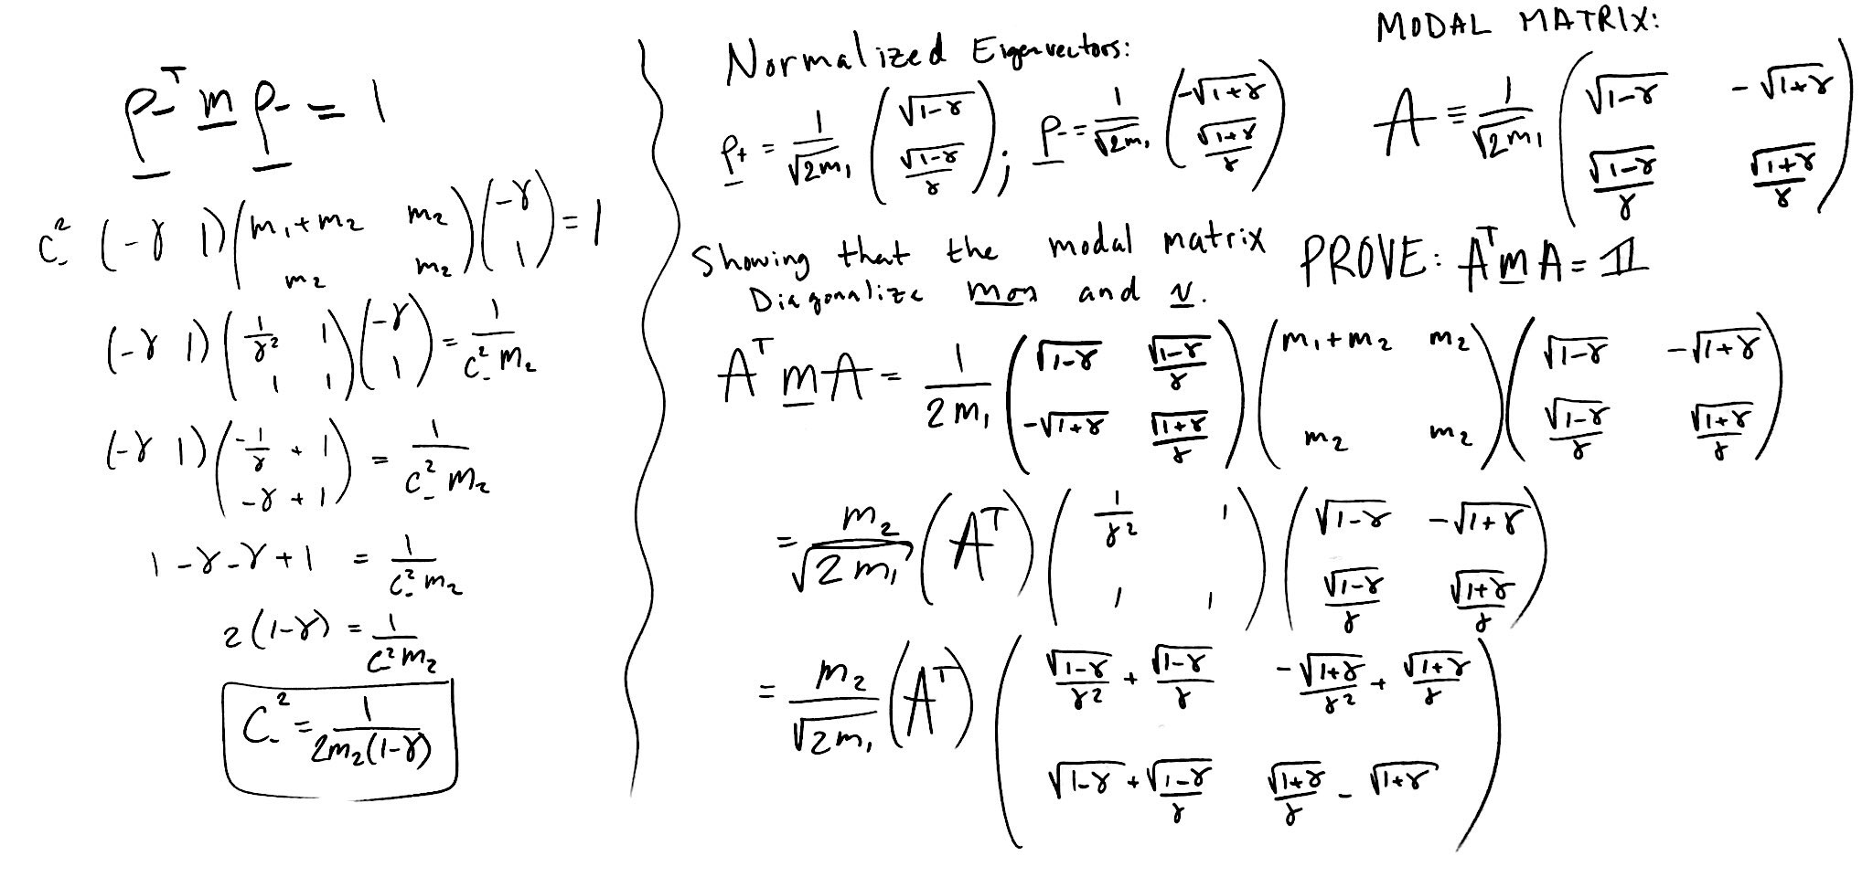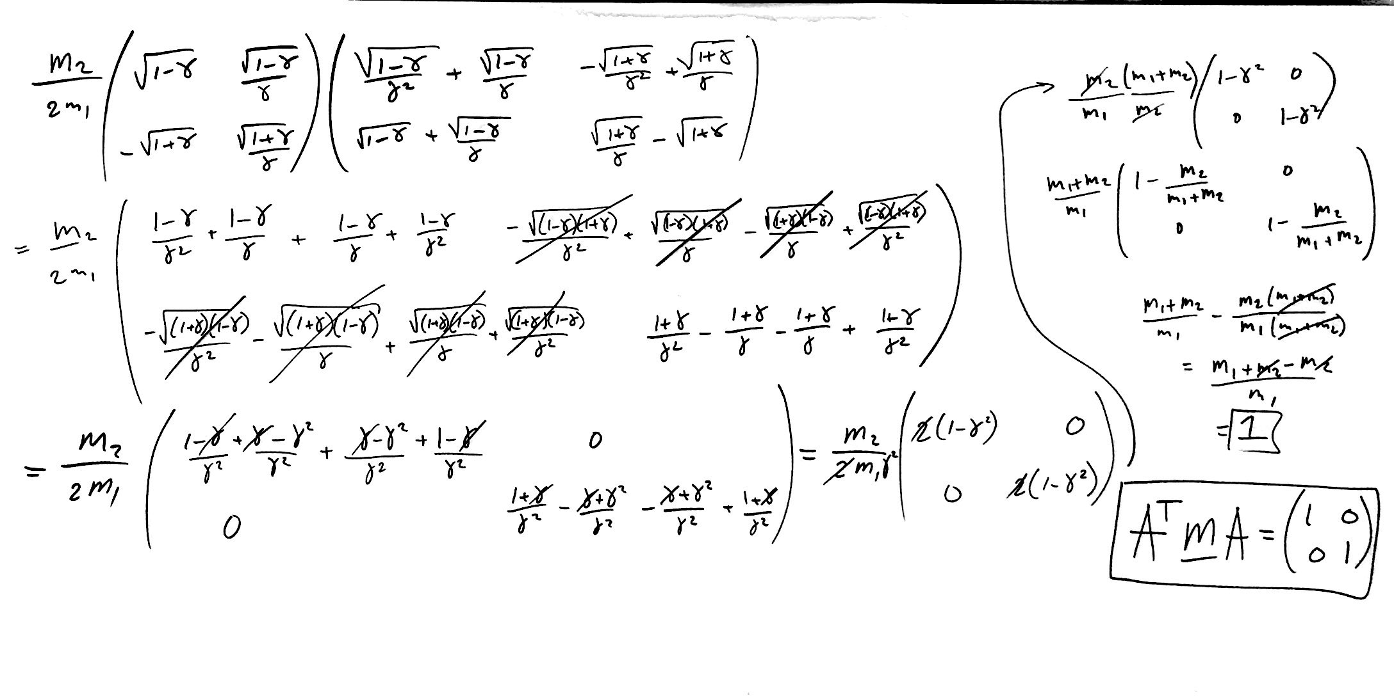

**Diagonalizing the potential matrix.**

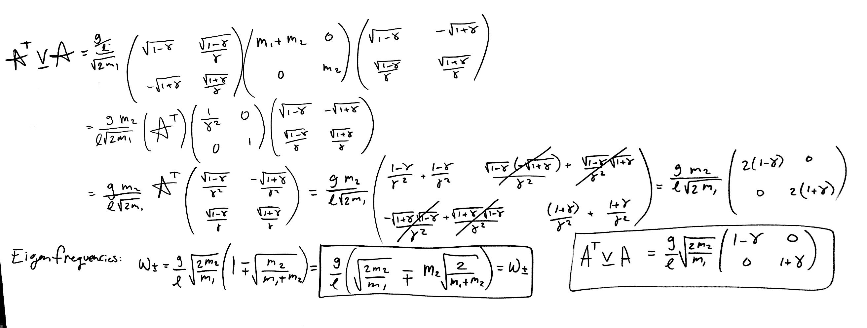

**Solving for the normal modes**

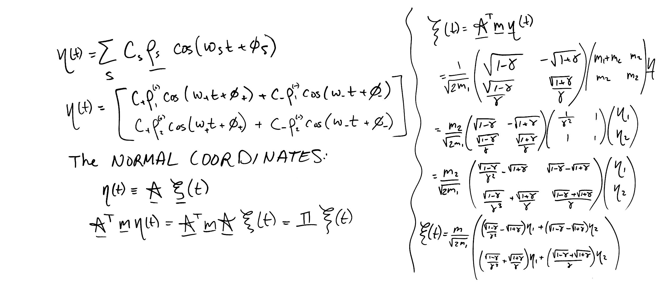

**Solving for particular initial conditions. There’s not much work shown here, I didn’t have a good idea of how to get the solutions quickly. I may try in Mathematica/Wolfram next time. I do however know that the system will follow a beat phenomena, where the pendula trade momentum back and forth, each following a beat function.**

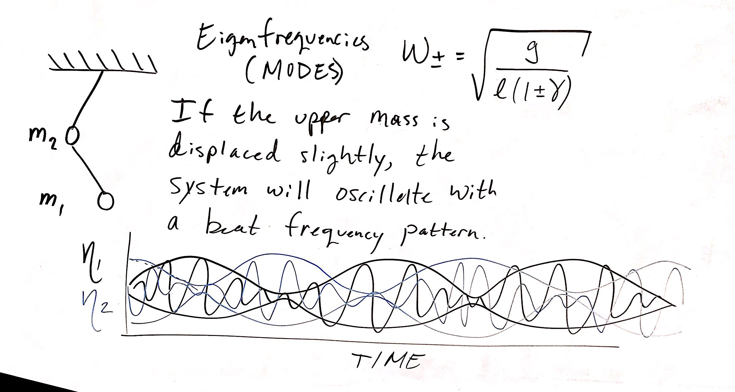

**Problem 2 setup**

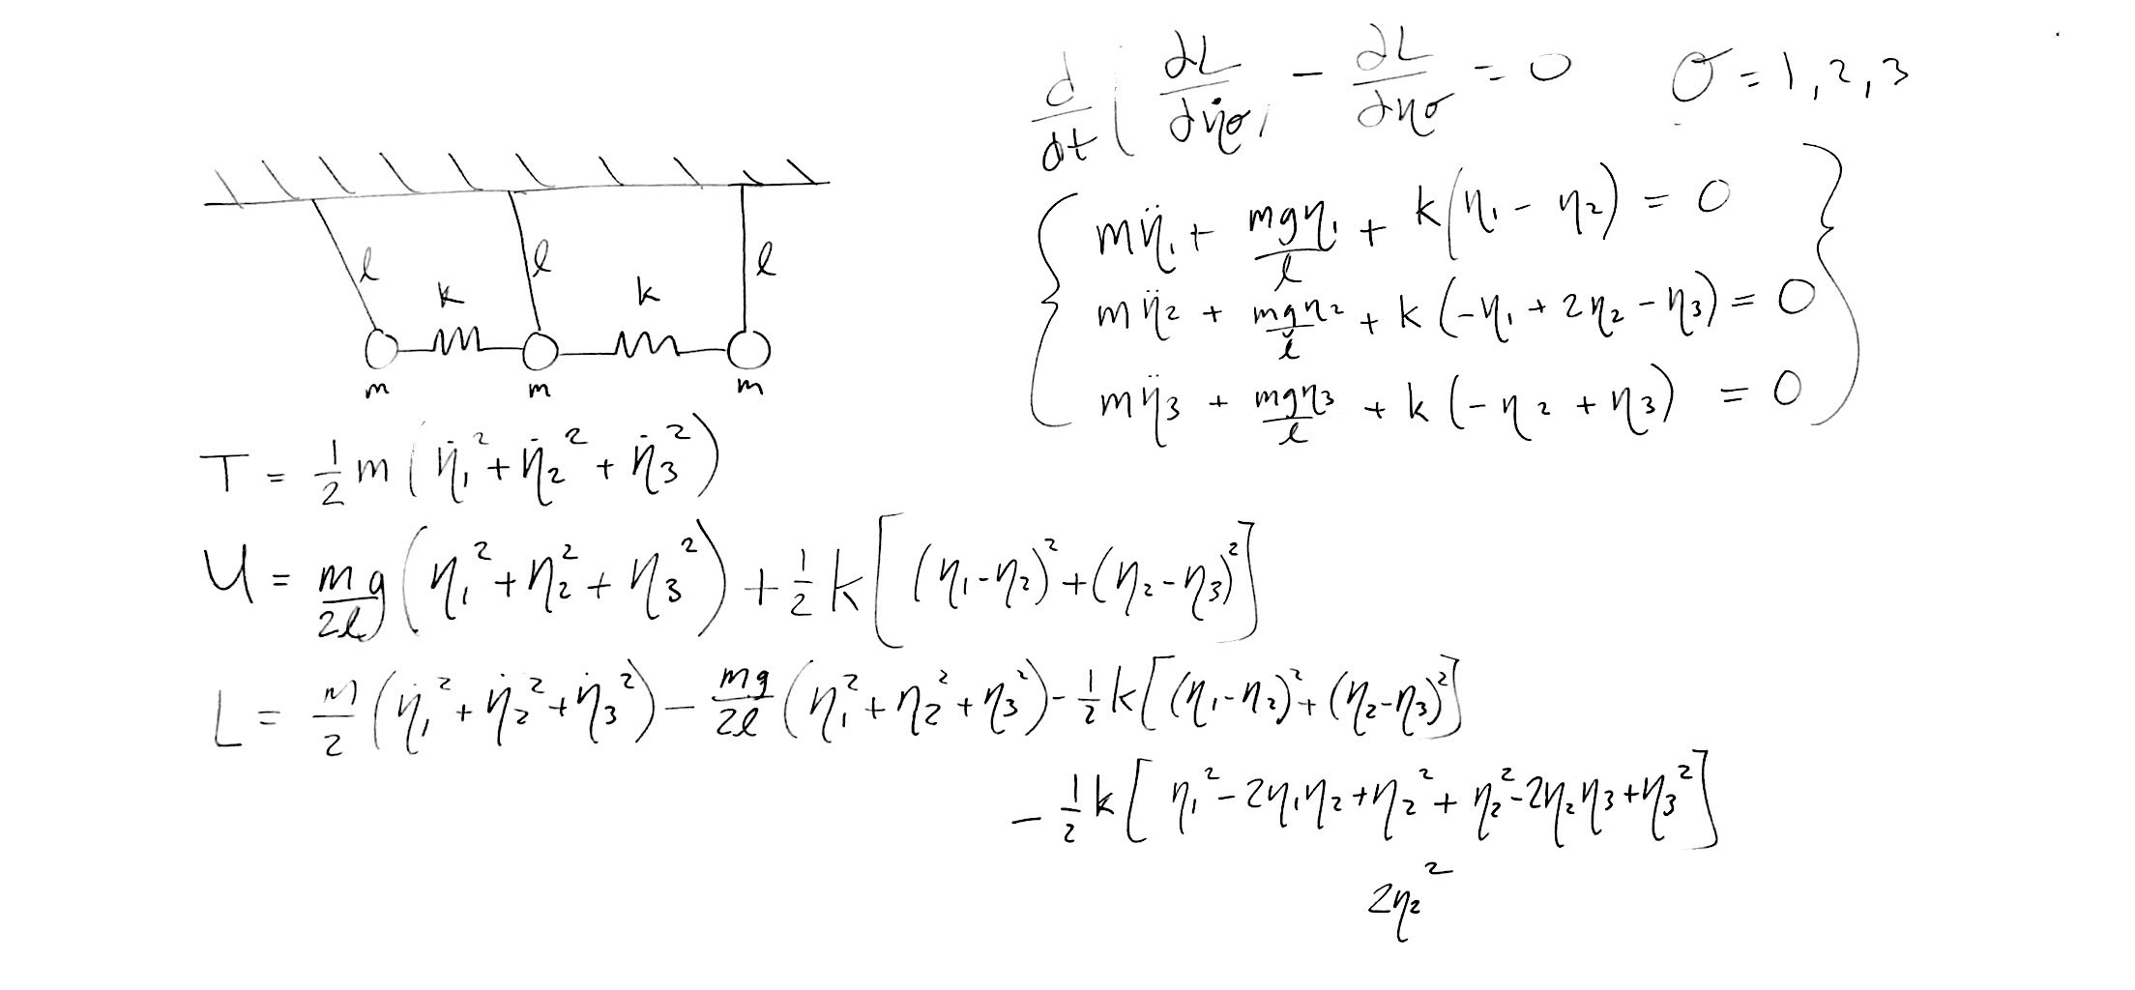

**After solving the Euler-Lagrange equation for all , we get a set of three equations that contain If we assume that will be a simple harmonic function, then we can rewrite . Then our system can succinctly be written in the following way:**

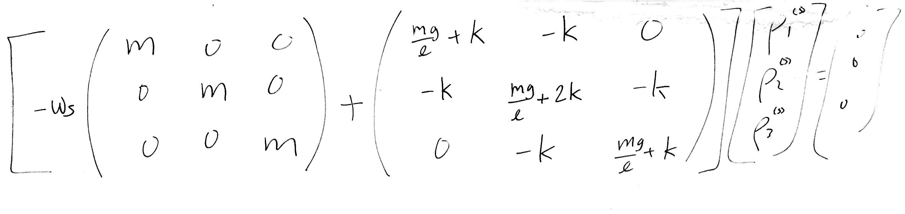

**By taking the determinant, I solved for the eigenfrequecies then wrote what modes they correspond to. The determinant was solved in Mathematica.**

